

CONTACT:

KENT THOMAS

Director of Marketing

kentt@ctcdefense.com

FOR IMMEDIATE RELEASE: September 27, 2010

9780 SW Freeman Drive Wilsonville, OR 97070 USA 877.778.1370 FAX 503.783.5334

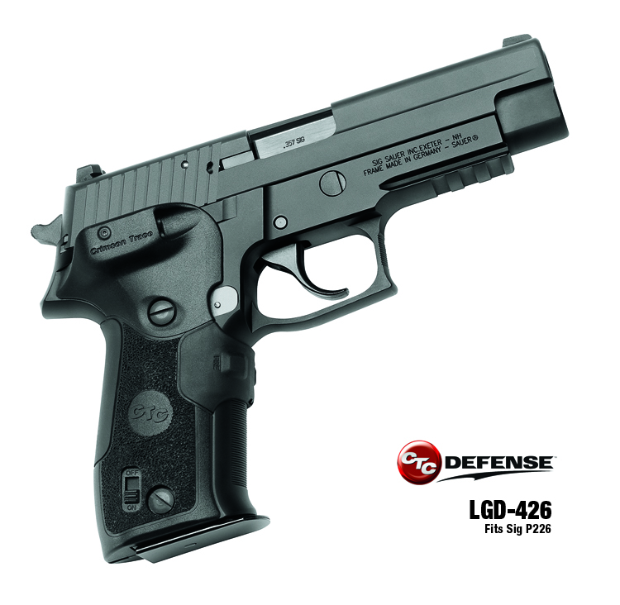

CTC Defense™ LAUNCHES Innovative Dual-Can™ Technology

**Wilsonville, OR** — CTC Defense, a division of Crimson Trace Corporation, announces a groundbreaking new laser sighting platform that provides for both Red and Infrared (IR) laser functionality in the same small, rugged and ergonomic grip package. To be introduced at the Modern Day Marine Show in Quantico, VA., the LGD-426 with   
Dual-Can Technology is built specifically for the Sig P226, which is the primary handgun for Naval Special Warfare, military and law enforcement professionals worldwide.

Utilizing innovative design and precise engineering that instinctively activates either the top red laser or bottom IR diode, the Dual-Can provides the Modern Warfighter something never before available in a pistol configuration: Two separate wavelengths of target acquisition for day or night operations, with activation in the same ergonomic housing. Extensive situational and environmental testing during the development of DCT™ assures that both diodes in the “Can” stay steady, true and hold zero once set. Switching from red laser to IR sighting is easily accomplished (with or without gloves) utilizing a Master Switch ergonomically built into the grip.

Weighing only 1.9oz, the Polymer grip incorporates rubber overmold panels and runs on two CR2032 batteries for up to 4 hours of intermittent use or 1.5 hours of continuous usage. As with all CTC-Defense products, the LGD-426 is 810G tested and certified to deliver confidence to today’s Modern Warfighter.

All CTC Defense products are proudly **Made in the USA.**

*CTC Defense Products Deliver The Progressive Capability That Today’s Modern Warfighter Must Have: The Means To Adapt And Overcome — To Succeed.*

All CTC Defense products are proudly **Made in the USA.**

*CTC Defense Products Deliver The Progressive Capability That Today’s Modern Warfighter Must Have: The Means To Adapt And Overcome — To Succeed.*

CONTACT:

KENT THOMAS

Director of Marketing

kentt@ctcdefense.com

specifications

Beam Intensity –   
RED – 5mW Peak, 635 nm, Class 1 laser  
IR – 0.7mW Peak, 850 nm, Class 2A

Dot Size – Approximately 0.5" Diameter at 50 feet

Batteries – Two CR2032, Over Four Hours of Laser Use.

Activation – Multi Faceted instinctive activation

MIL-STD-810G Certified

features

* Fits Sig P226
* Weight: 1.9 oz with batteries
* Polymer Housing with Rubber Overmolded   
  Activation Pad
* Gold-Plated Battery and Activation contacts
* Compact 5.6mm Diode
* Precise Windage and Elevation Adjustments
* Two Screw, Tab Lock Attachment
* Waterproof
* Independent mode selector/Master Switch

# # #

Page 2

FOR IMMEDIATE RELEASE: September 27, 2010

9780 SW Freeman Drive Wilsonville, OR 97070 USA 877-778-1370 FAX 503.783.5334