

CONTACT:

KENT THOMAS

Director of Marketing

kentt@ctcdefense.com

FOR IMMEDIATE RELEASE: September 27, 2010

9780 SW Freeman Drive Wilsonville, OR 97070 USA 503.783.5333 800.442.2406 FAX 503.783.5334

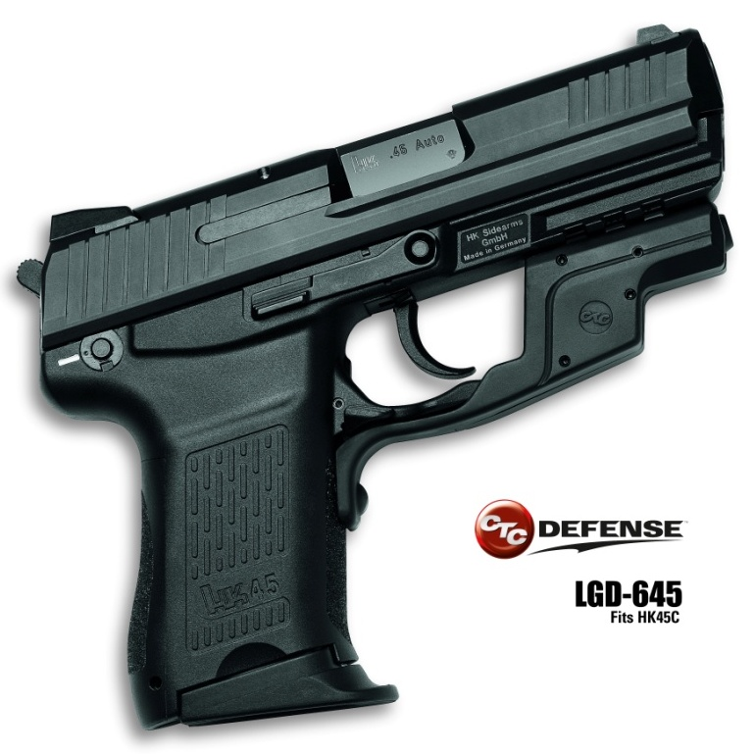s

CTC Defense™ Announces Laserguard® for HK 45 Compact (HK 45C)

**Wilsonville, OR** — CTC Defense, a division of Crimson Trace Corporation, has announced a new Laserguard sighting device for the HK 45 Compact, the new   
LGD-645.

Specifically designed to fit securely around the trigger guard of the HK 45c, this rugged, waterproof compact laser sighting device is instinctively activated by a rubber overmolded switch located directly under the trigger guard on the front-strap of the pistol. This proprietary design assures that when the gun is held in a shooting grip, the laser activates immediately and reliably.

Other features include a battery compartment easily accessible on the side of the Laserguard with a lanyard that secures the battery door to the unit at all times. This facilitates changing the battery without having to remove the unit from the gun, ensuring point of aim to remain the same after a battery change.

The LGD-645 has passed repeated rigorous live-fire exercises and environmental   
810G testing that ensures tactical proficiency and reliability required of the Military Professional and today’s Warfighter.

All CTC Defense products are proudly **Made in the USA.**

*CTC Defense Products Deliver The Progressive Capability That Today’s Modern Warfighter Must Have: The Means To Adapt And Overcome — To Succeed.*

[**Download High Resolution Image**](http://www.crimsontrace.com/images/articles/pr/HK_45C_press_pic.jpg)

CONTACT:

KENT THOMAS

Director of Marketing

kentt@ctcdefense.com

specifications

Beam Intensity –   
RED – 5mW Peak, 635 nm, Class 3R laser  
IR – 0.7mW Peak, 850 nm

Dot Size – Approximately 0.5" Diameter at 50 feet

Batteries – One 1/3N 3V Lithium or Two 357 Silver Oxide Batteries; Over Four Hours of Laser Use

Activation – Front-located Integrated Momentary Pressure Switch

MIL-STD-810G Certified

features

* Fits Heckler and Koch (HK) 45C
* Weight: 0.5 oz/15.6g with batteries
* Polymer Housing with Rubber Overmolded   
  Activation Pad
* Gold-Plated Battery and Activation contacts
* Compact 5.6mm Diode
* Precise Windage and Elevation Adjustments
* Three-Screw, Tab Lock Attachment

# # #

Page 2

FOR IMMEDIATE RELEASE: September 27, 2010

9780 SW Freeman Drive Wilsonville, OR 97070 USA 503.783.5333 800.442.2406 FAX 503.783.5334